1.SCRAP IRON MS – HEAVY MIX

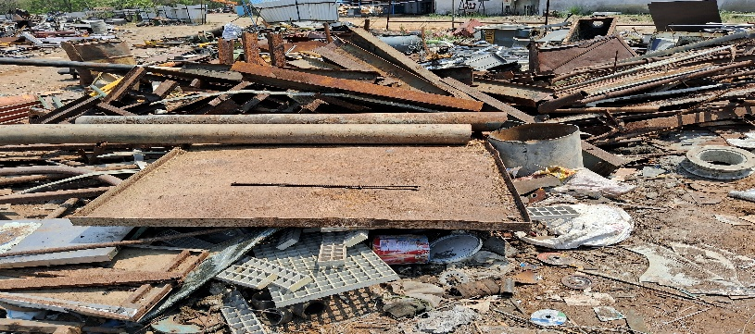

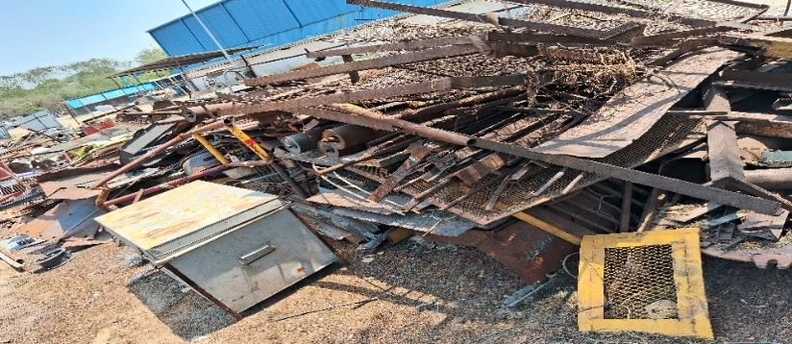

2. SCRAP IRON MS - COLLECTOR BAR

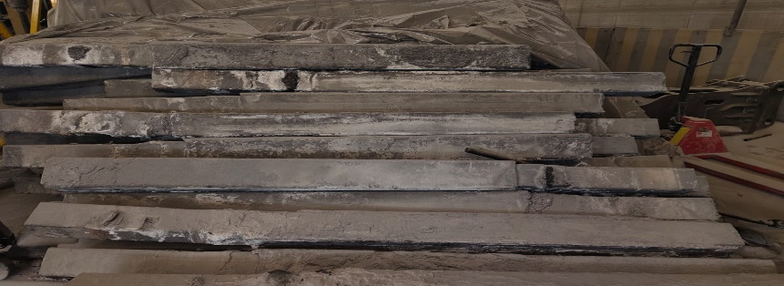

3. SCRAP IRON MS - LIGHT MIX

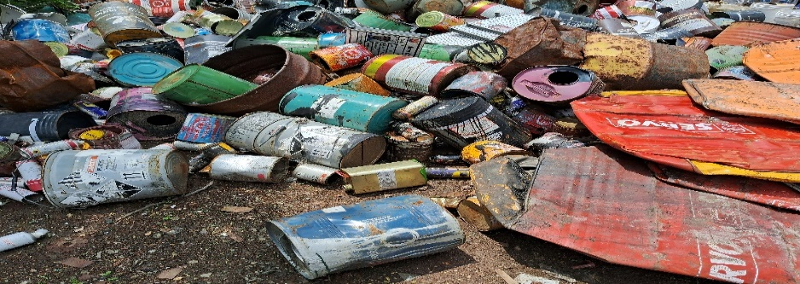

4. SCRAP IRON MS - FLATS/STRIPS GI & MS MIXED

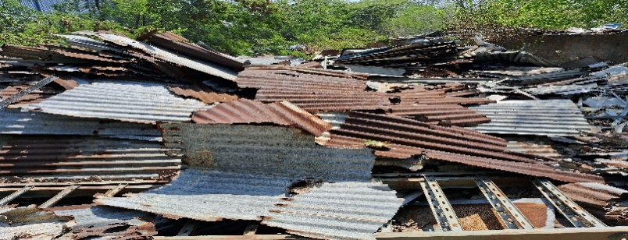

5. SCRAP CAST IRON/STEEL - ITEMS & PARTS

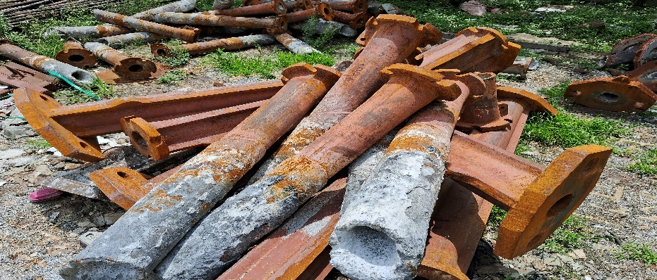

6. COPPER COLLECTOR BAR SCRAP

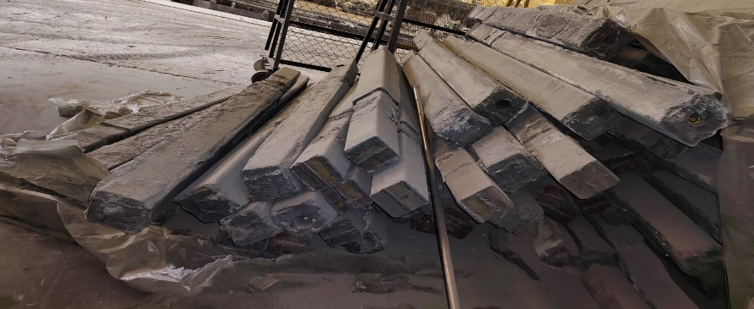

7. SCRAP IRON GRINDING WHEEL

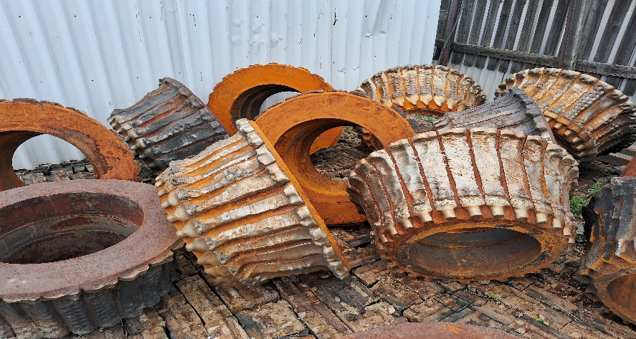

8. SCRAP TOOLS-HTS WIRE ROPE & SLINGS

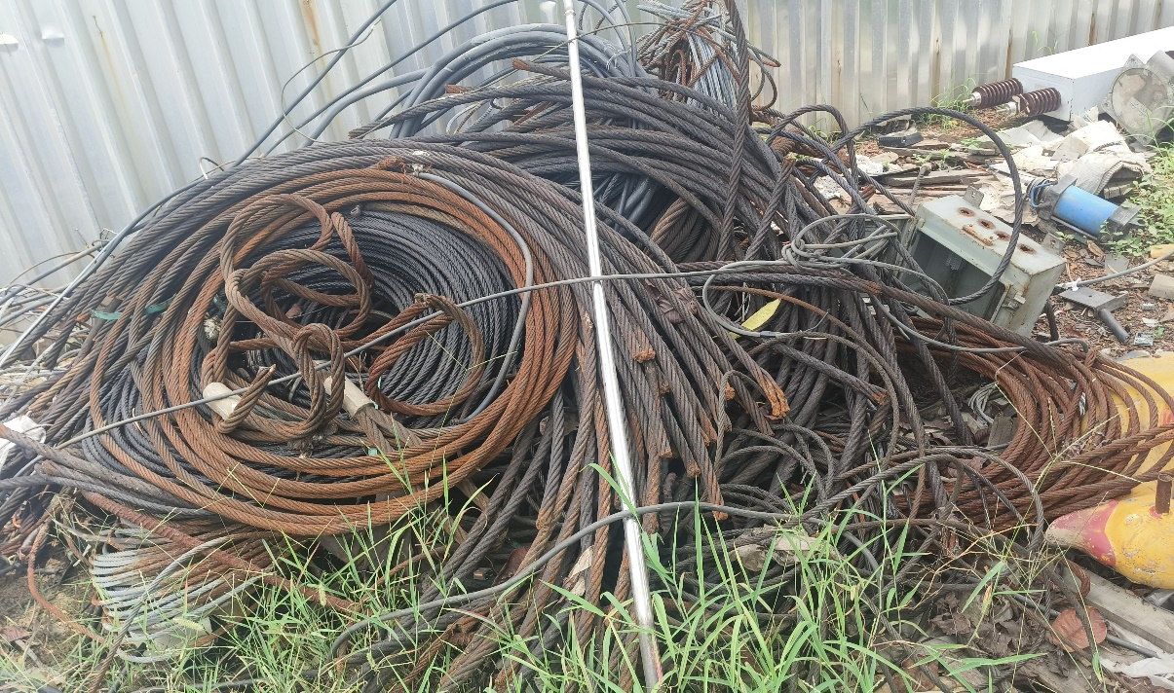

9. SCRAP PAPER - ALL MIXED , CARTON/CARD BAORD/SPOOL/SHEET ETC

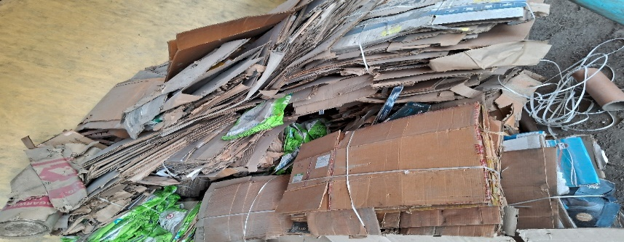

10. SCRAP IRON-USED AUTO PARTS & SPARES

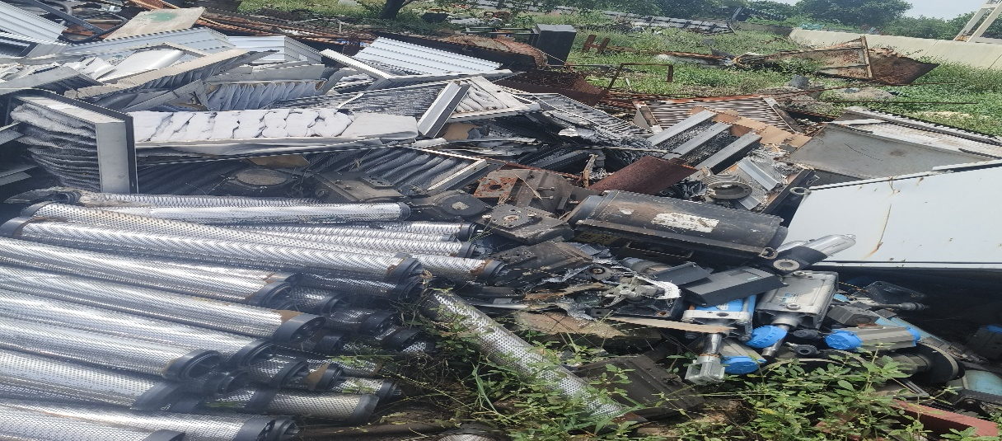

11. FURNACE & SLAG SCRAP

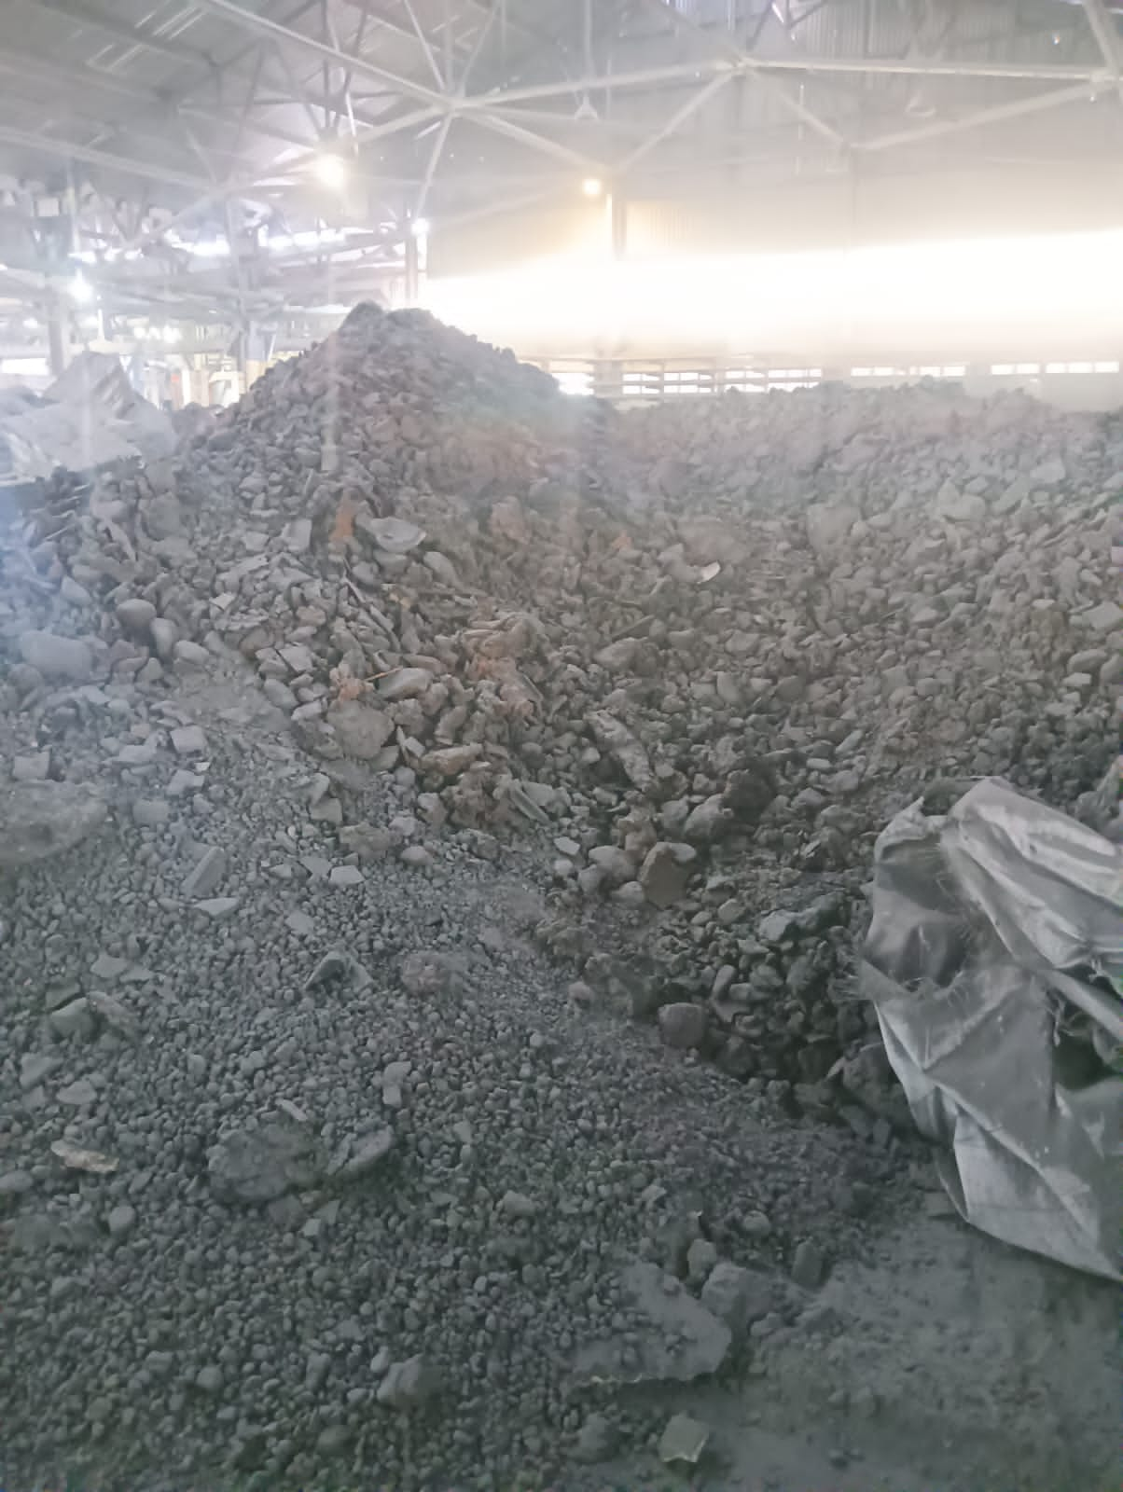

12. BEARING SCRAP

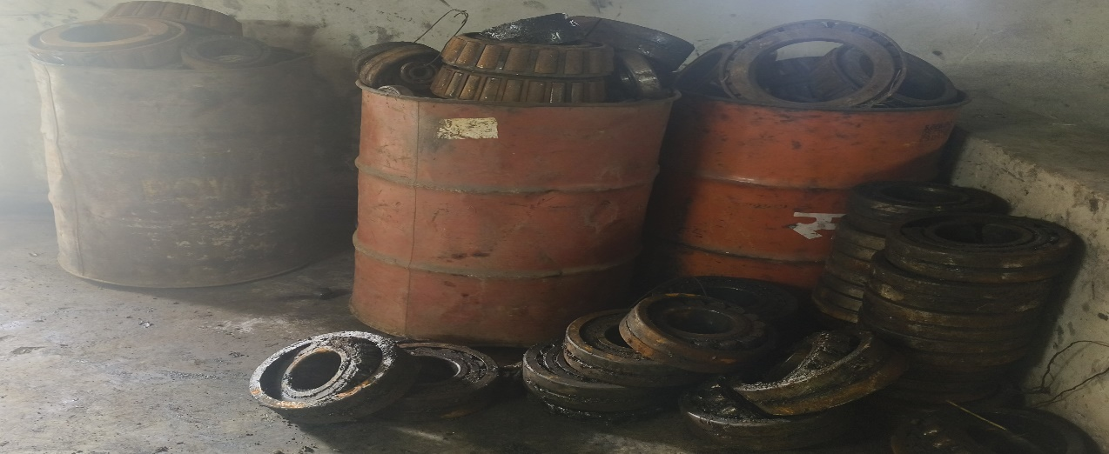

13. ALUMINIUM CABLE SCRAP

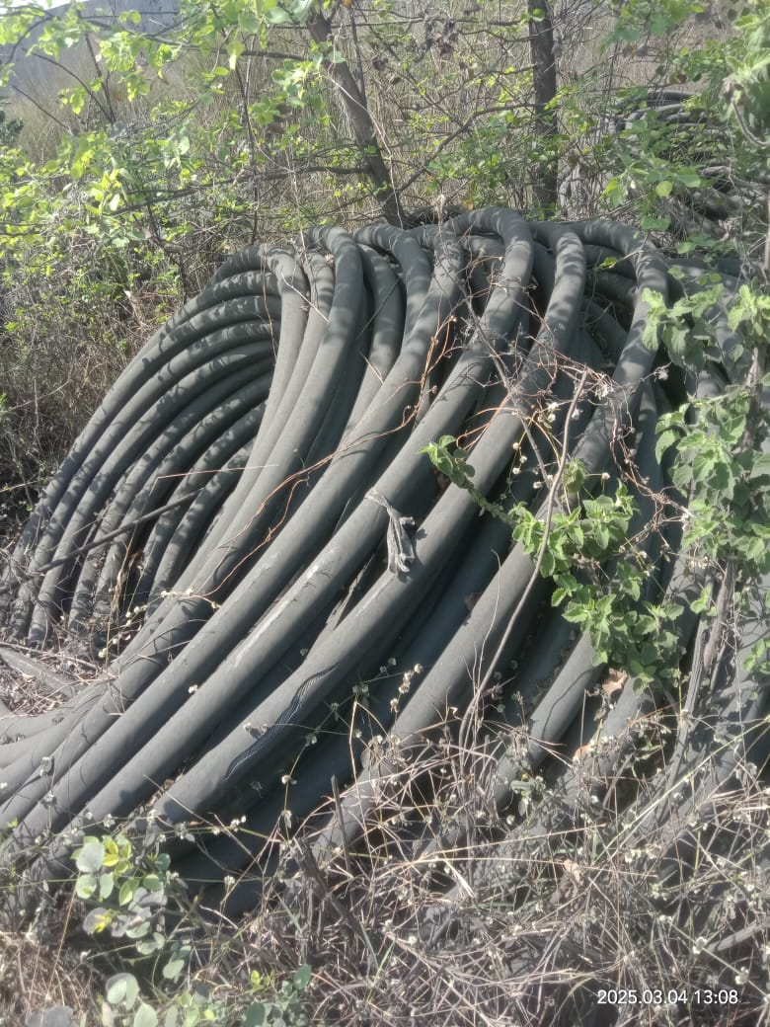

14. SCRAP CERAMIC - FILTER, ENGROSSED WITH ALUMINIUM METAL

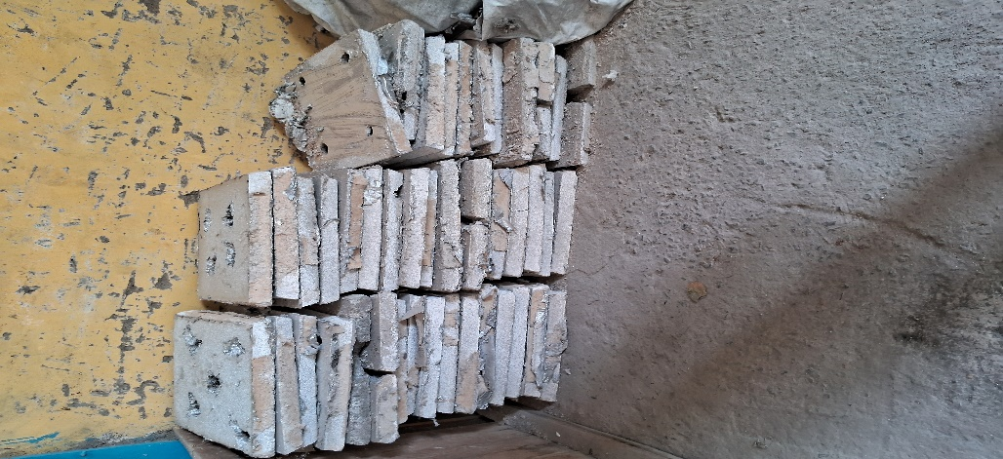

15. SCRAP RUBBER - HOSE/SHEET/CUT PIECE MIXED

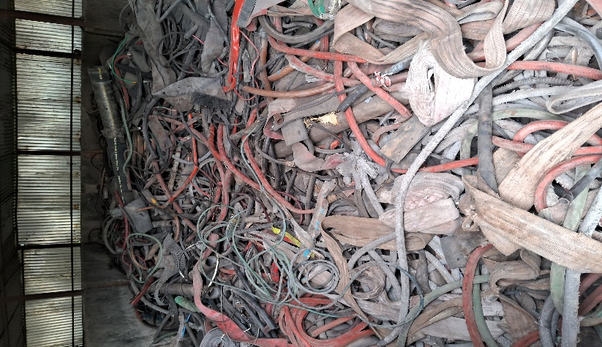

16. PLASTIC CAN/DRUM 200 LTR

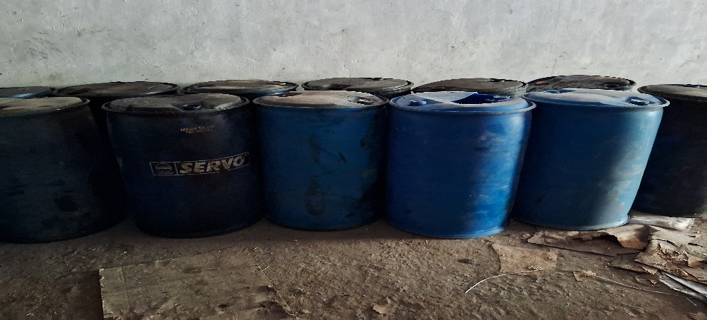

17. PLASTIC SCRAP, BAGS,TORN BAGS & CEMENT BAGS

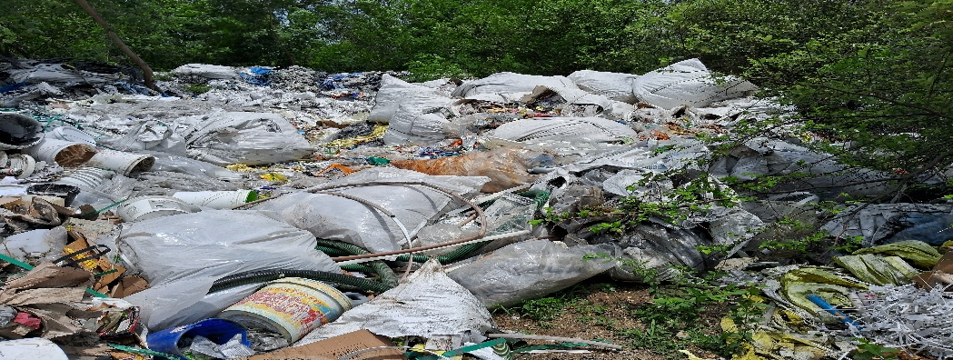

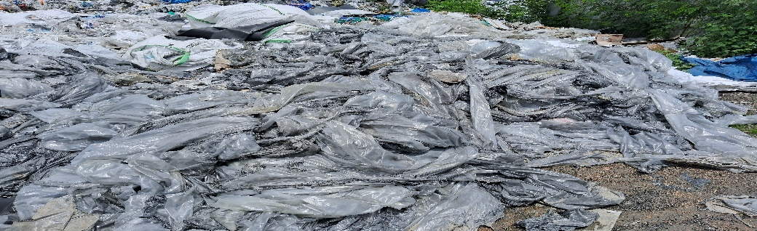

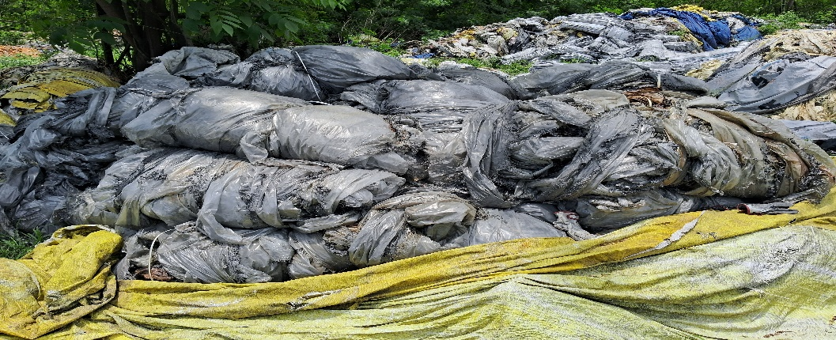

18. ALL KINDS OF PLASTIC MIX SCRAP

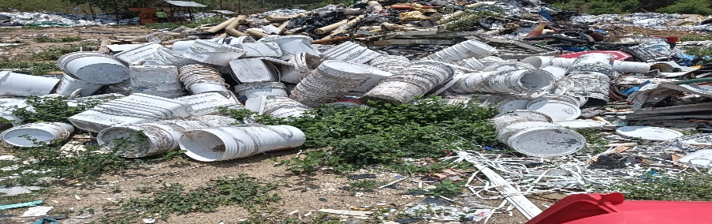

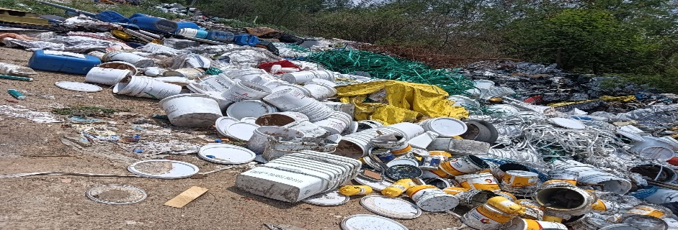

20. SCRAP HAZARDOUS -e-WASTE(REFRIGERATOR COMPRESSOR & ACCESSORIES )

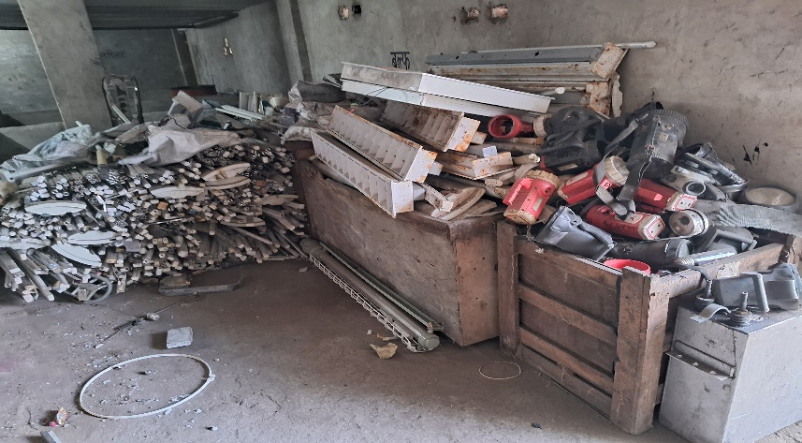

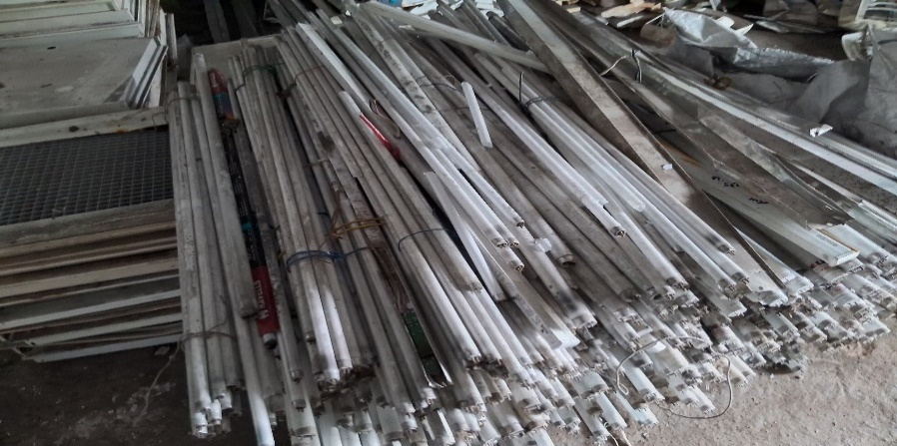

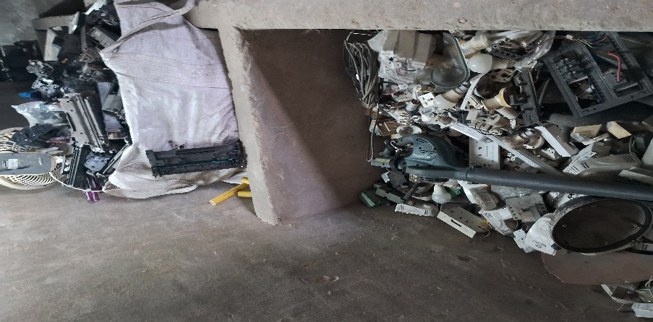

21. USED & WASTE OIL WITH DRUM

