1. USED OIL (WATER & SLUDGE MIX) Separation not allowed

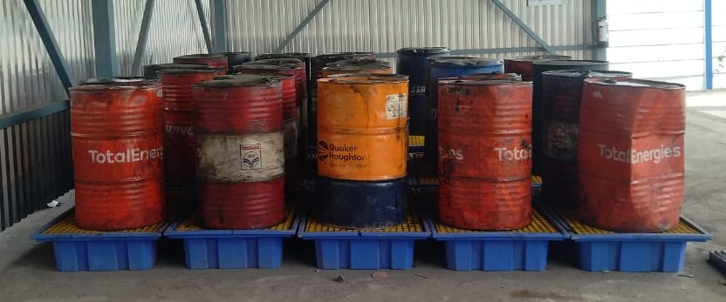

1. SCRAP OIL DRUMS

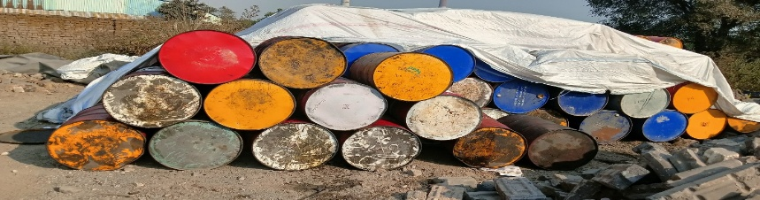

3 SCRAP CONVEYOR BELT

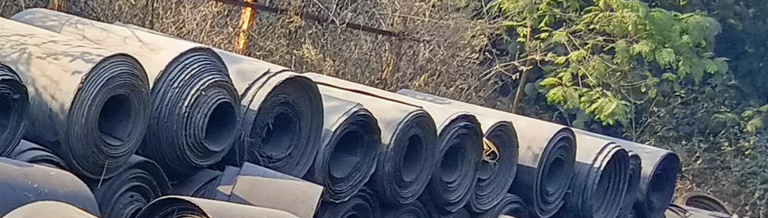

4 SCRAP MISC RUBBER

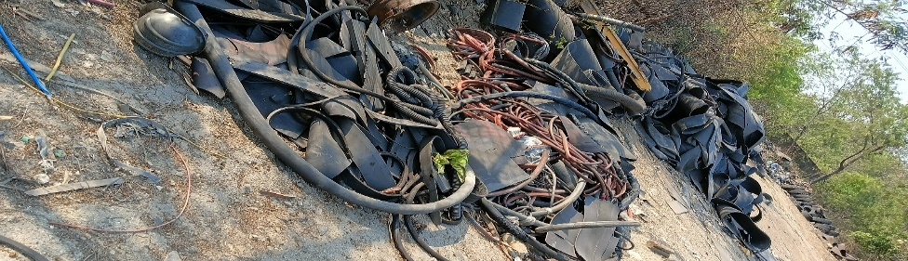

5 SCRAP JUMBO BAGS

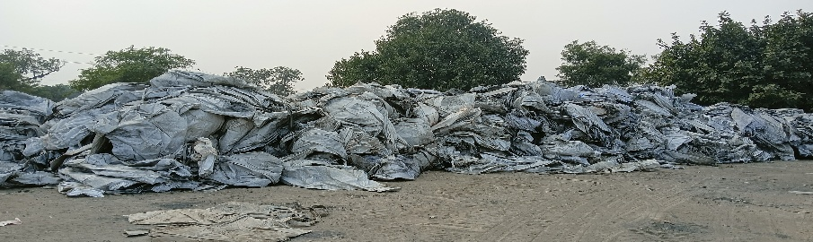

6 SCRAP HDPE/LDPE/PP BAGS, FILMS, FABRIC&TARPAULIN

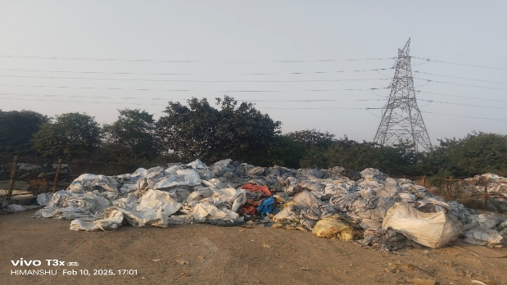

7 SCRAP IDLE ASSET-BRICKS PLANT

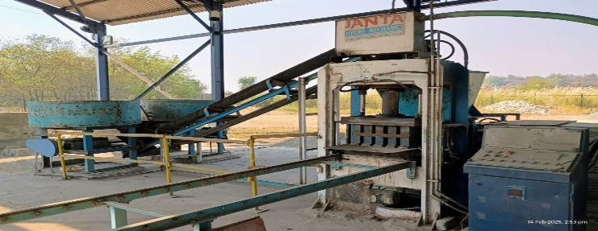

8 SCRAP OF REFACTORY TOP BLOCK

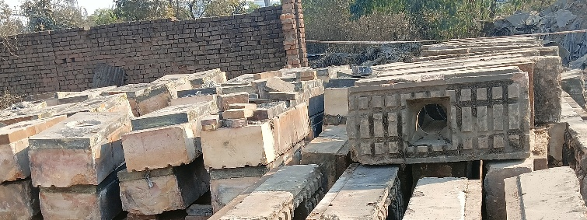

9 SCRAP MIXED MS

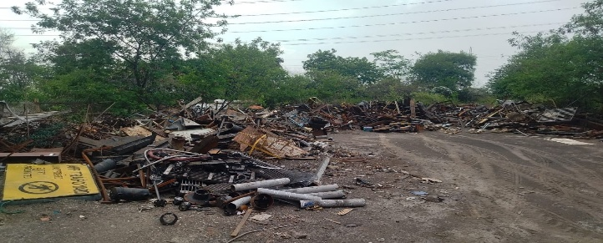

10 SCRAP COLLECTOR BAR COPPER INSERTED

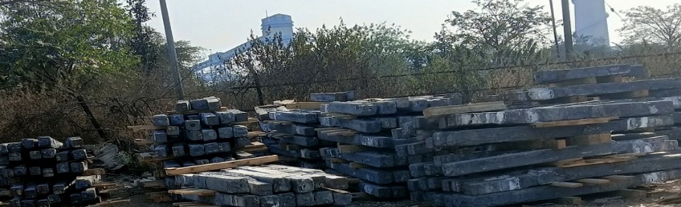

11 SCRAP IRON GALVANISED - SHEETS/FLATS/STRIPS

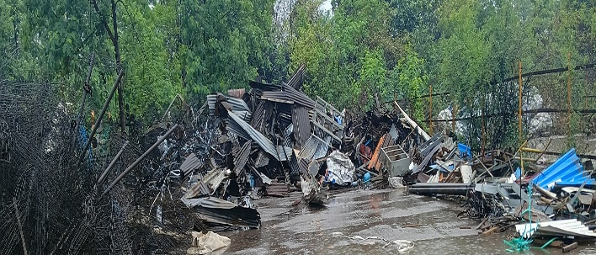

12 SCRAP SWING HANGER (ALLOY METAL)

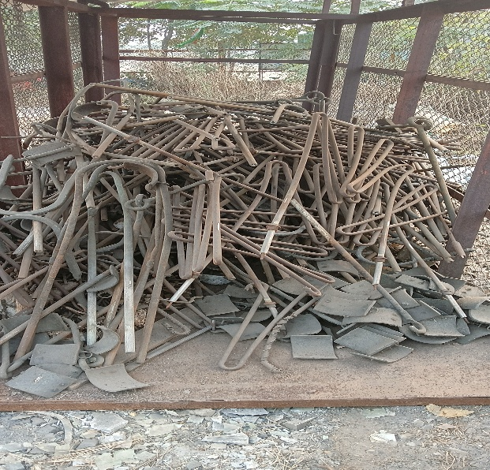

13 SCRAP IRON CHIPS

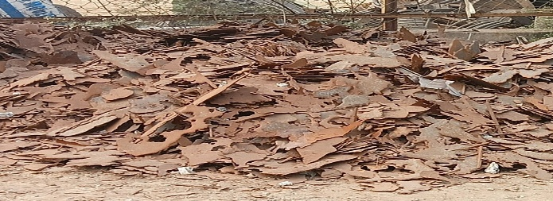

14 SCRAP ACTIVATED ALUMINA BALL

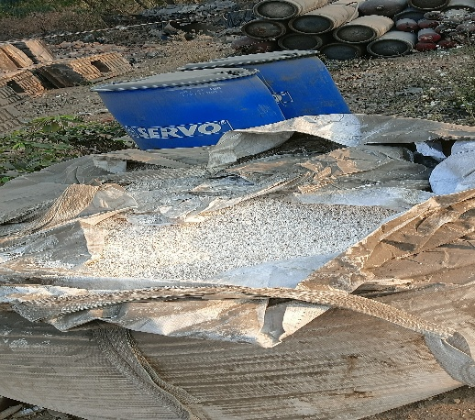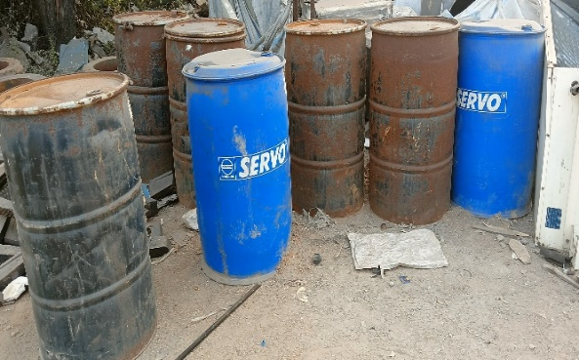

15 SCRAP CARBON SLAB

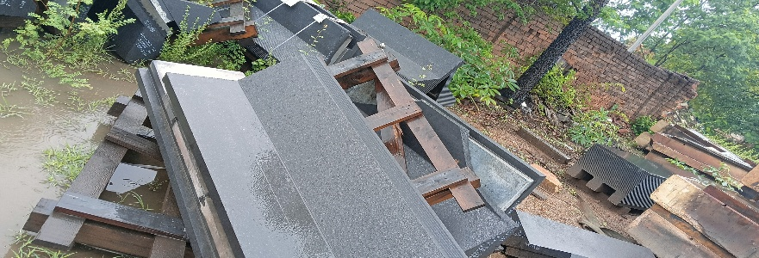

16 SCRAP SS

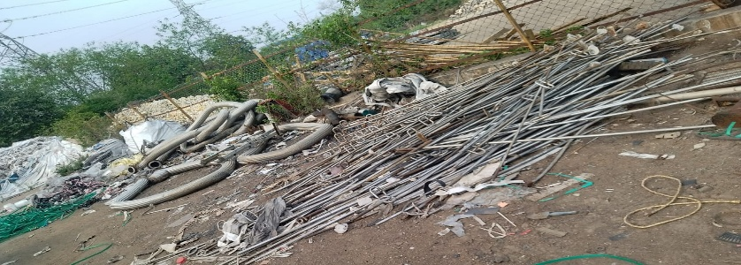

17 SCRAP SUSPENDED MAGNETIC METAL

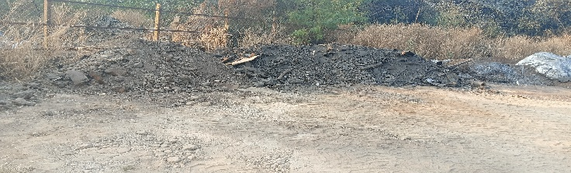

18 SCRAP CAST IRON DUST

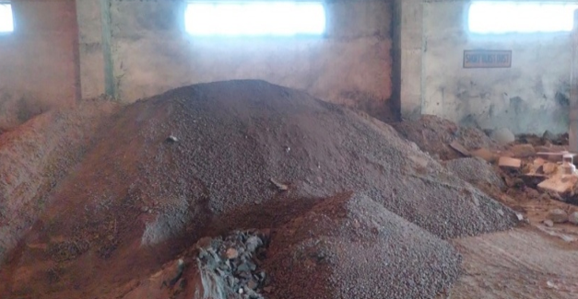

19 SCRAP FURNACE SLAG

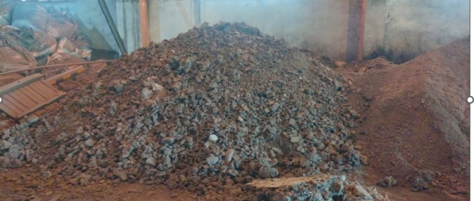

20 SCRAP BI-METAL CLAD

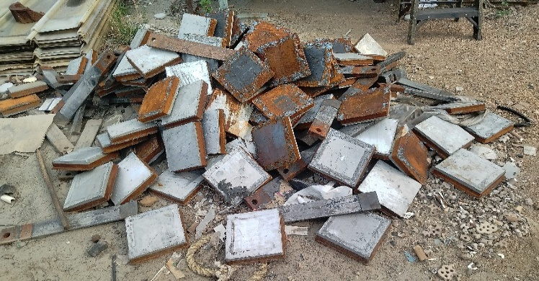

21 SCRAP BRASS TURNING

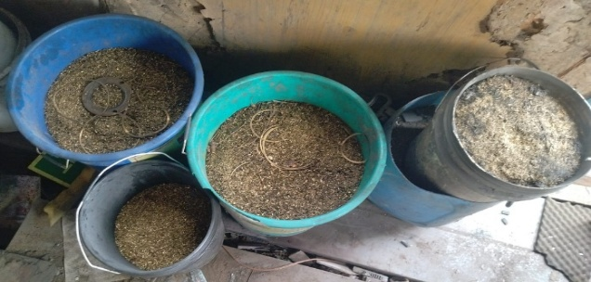

22 SCRAP WOODEN - IMPORTED (PLYWOOD ATTACHED)

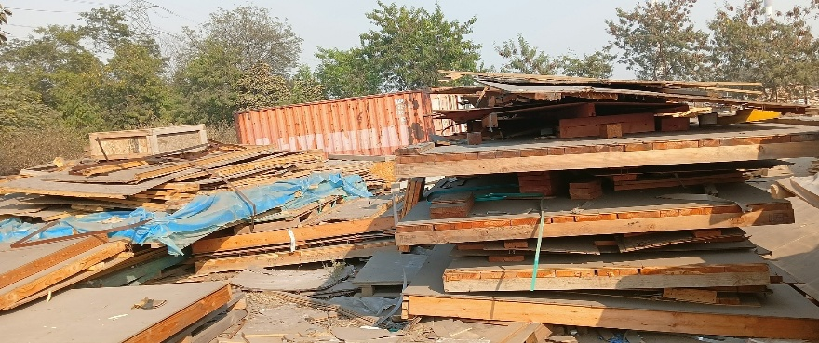

23 SCRAP WOODEN IMPORTED

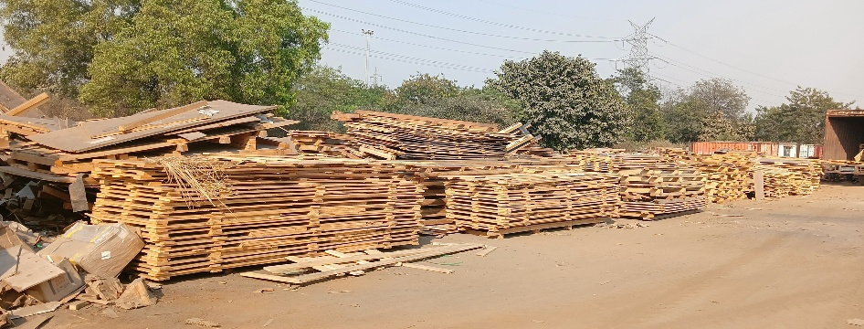

24 SCRAP FIREWOOD

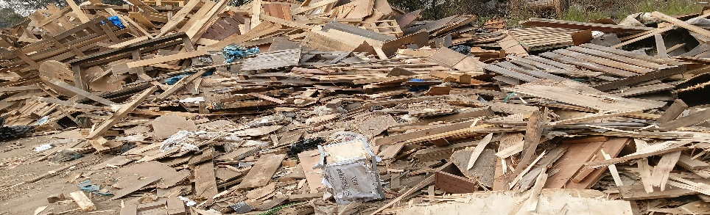

25 SCRAP FILTER CLOTH

