**1-IDLE-AMBULANCE**

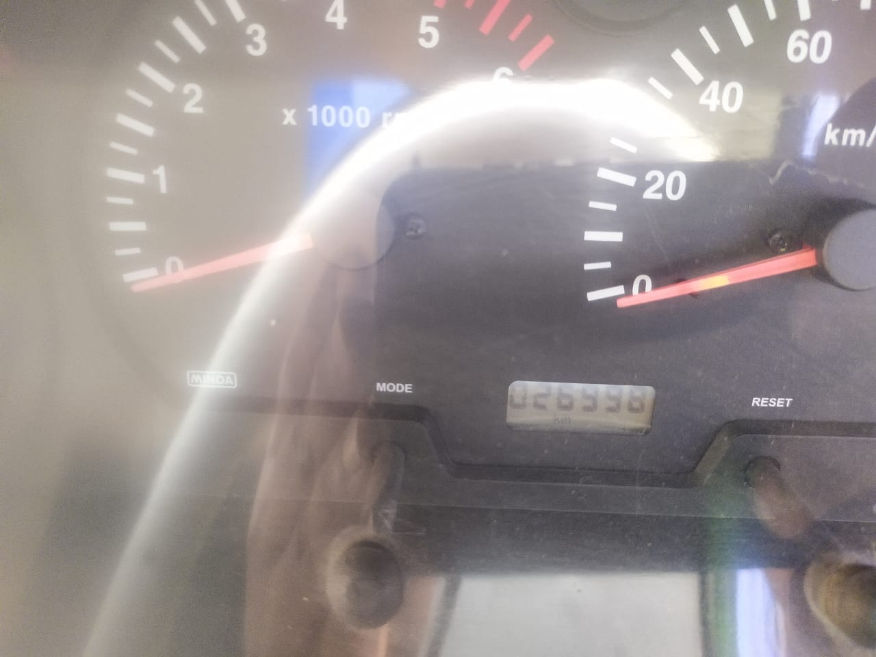

**2-IDLE ELC MACHINE**

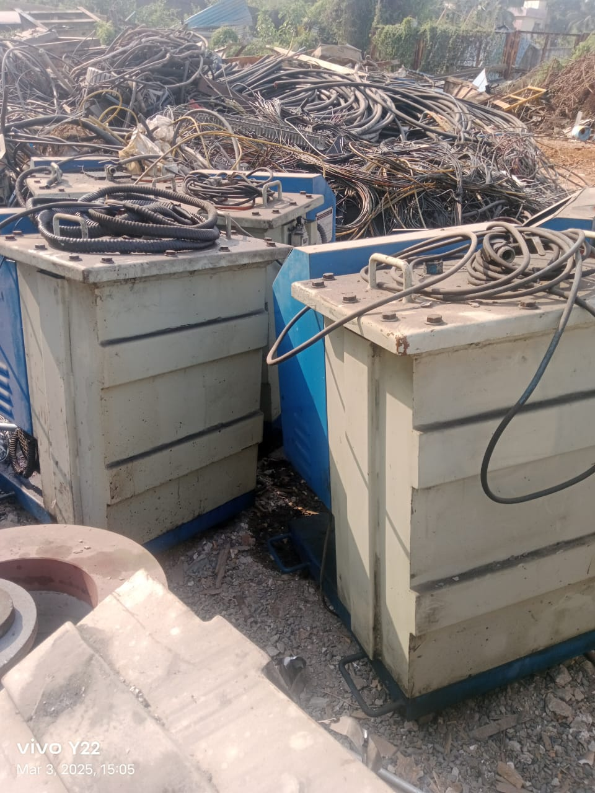

**3-JUMBO BAG:**

**4-POLYELECTROLYTE,MAXFLOC-8200**

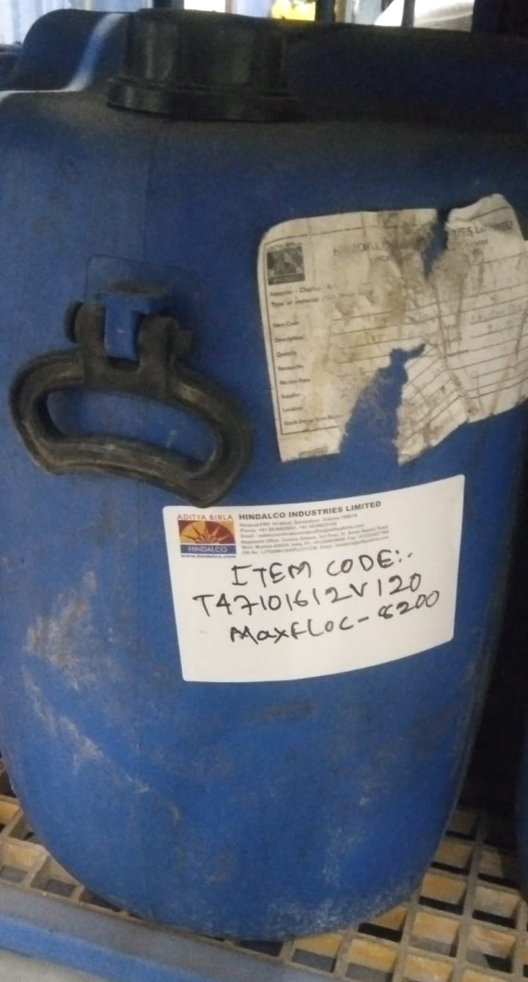

**5-SCRAP IRON ROD (TMT)**

